BIT 4107 – MOBILE APPLICATION DEVELOPMENT
ENHANCED PROFESSIONAL STUDENT LOGBOOK
STUDENT NAME: SHALOM KIBOKO
ADMISSION NUMBER: BIT/2025/39237
SCHOOL/FACULTY: COMPUTING AND INFROMATICS
PROGRAMME: BACHELOR OF SCIENCE IN INFORMATION TECHNOLOGY
ACADEMIC YEAR: 2
SEMESTER: 2
LECTURER: MR.NYORO MICHAEL
PHONE NUMBER: 0725865117

Contents
WEEK 1: INTRODUCTION TO MOBILE APPLICATION DEVELOPMENT - 2 -
Week 1Summary: - 5 -
WEEK 2: MOBILE DEVELOPMENT ENVIRONMENT - 6 -
Week 2 Summary : - 6 -
WEEK 3: USER INTERFACE DESIGN - 8 -
Week 3 Summary - 10 -
WEEK 4: EVENT HANDLING AND USER INTERACTION - 11 -
Week 4 Summary: - 12 -
WEEK 5: DATA MANAGEMENT - 13 -
Week 5 Summary: - 13 -

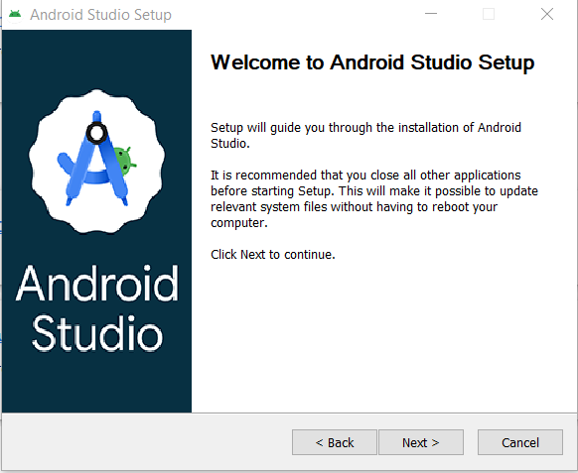
WEEK 1: INTRODUCTION TO MOBILE APPLICATION DEVELOPMENT

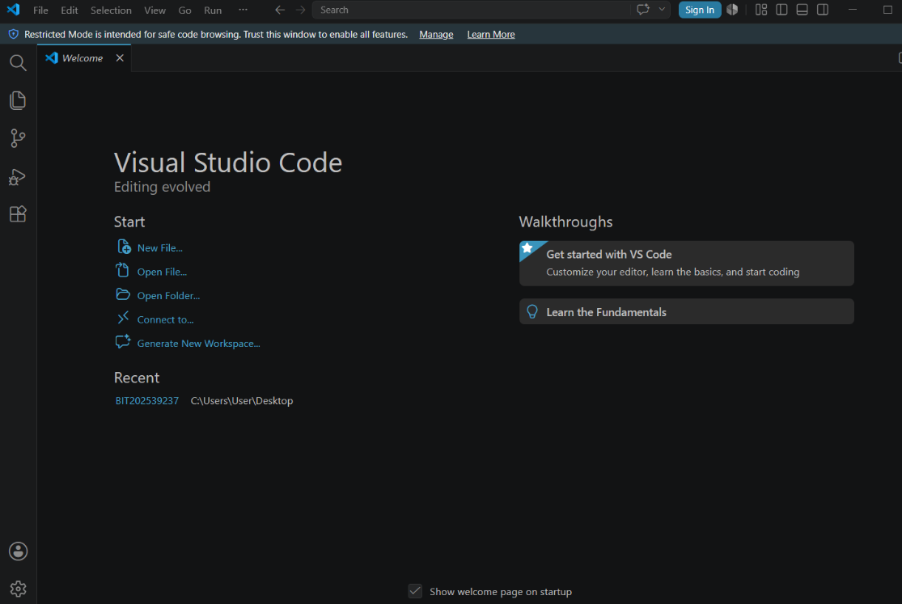
Figure 1: Android installation

Figure 2:VS Code

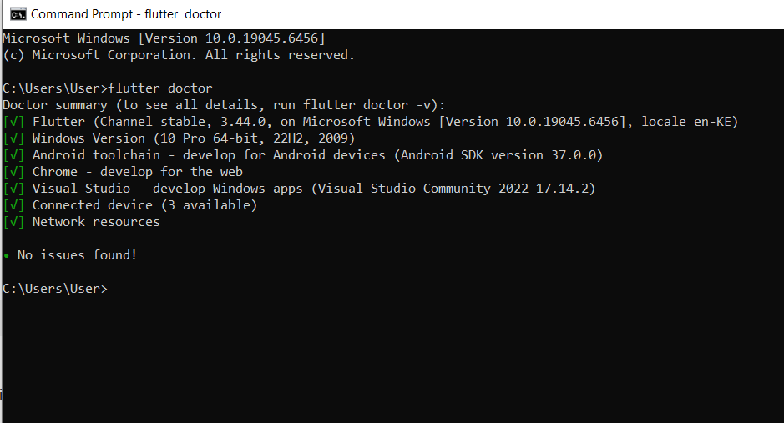

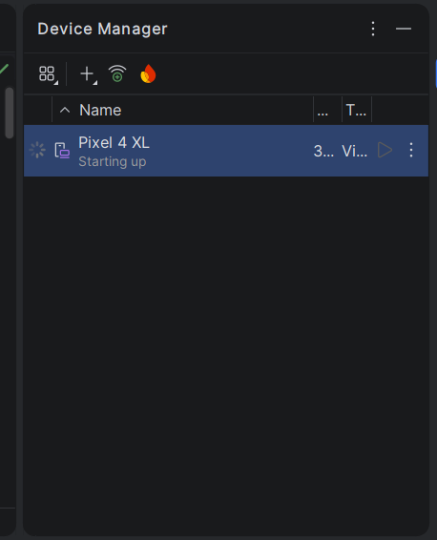
Figure 3:Flutter doctor prompt

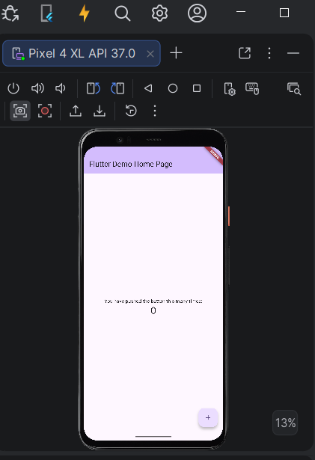
Figure 4: Emulator

Figure 5:Flutter default

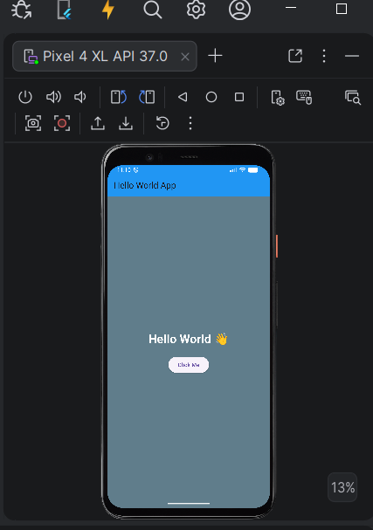

Figure 6: First App

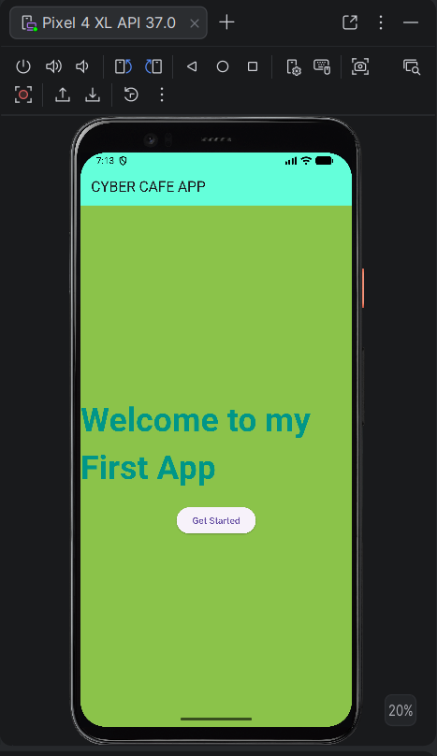

Figure 7:Modified App
Tools used:
- Android Studio
- Flutter SDK
- Dart programming Language
- Android Emulator

Week 1Summary:
In this week, I successfully set up my mobile development environment and created my first Flutter application. I learned how different tools work together in app development and gained basic understanding of UI structure and Flutter widgets. The experience improved my confidence in mobile app development.
Lessons:
I learned how to set up a mobile development environment using Android Studio, VS Code, and Flutter. I also understood the basics of cross-platform development and how Flutter widgets are used to build user interfaces. Additionally, I gained experience running and modifying my first mobile application.

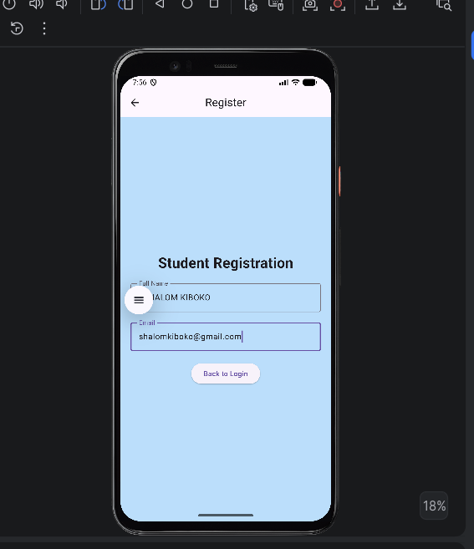
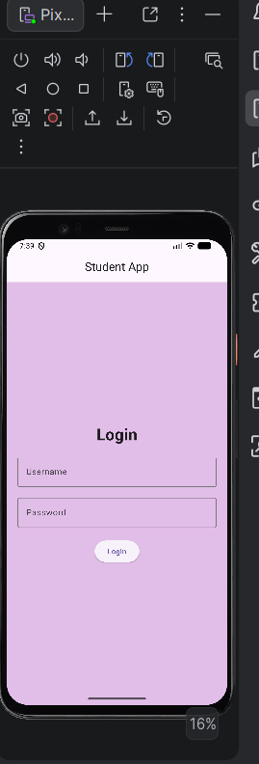
WEEK 2: MOBILE DEVELOPMENT ENVIRONMENT

Figure 1:Login Screen Figure 2:Registration Screen

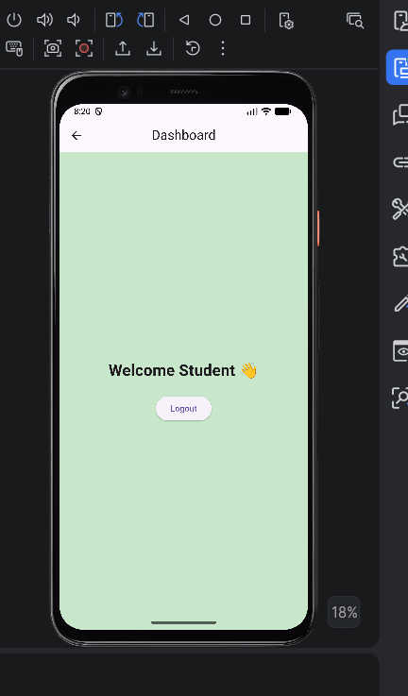

Figure 3: Dashboard Screen

Week 2 Summary :
In Week 2, I learned programming concepts and how they are applied in mobile app development using Flutter. I built simple UI components and screens such as login and registration pages and gained basic understanding of navigation and connecting applications to data sources.
Lessons:
I learned how to apply programming fundamentals such as variables, functions, and classes in mobile development. I also gained skills in building user interfaces using Flutter widgets, creating multiple screens, and navigating between them. Additionally, I was introduced to basic API concepts and local data handling.

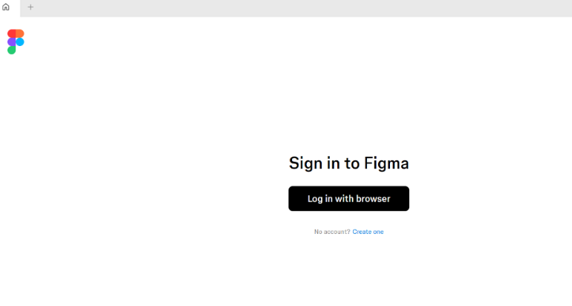
WEEK 3: USER INTERFACE DESIGN

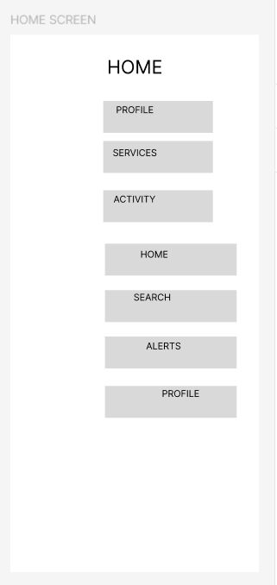
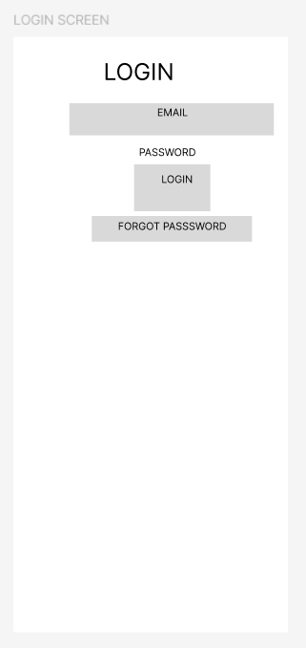
Figure 1: Figma Setup

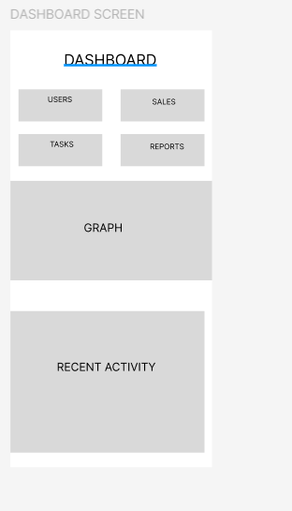
Frame 1: Login Screen Frame 2: Home Screen
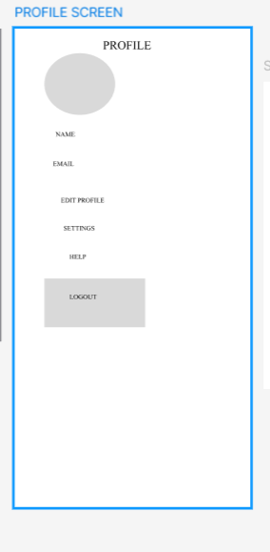

Frame 3: Dashboard Screen Frame 4: Profile Screen

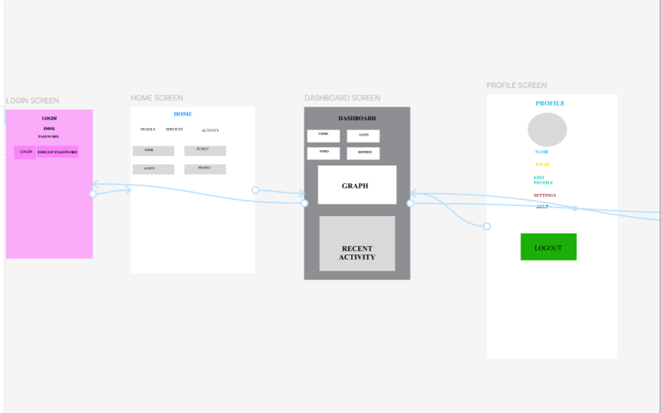
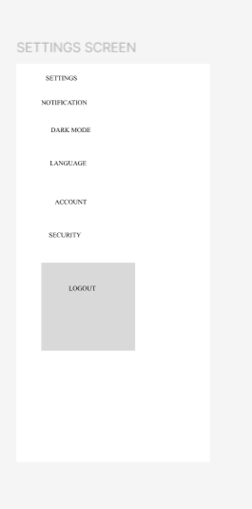

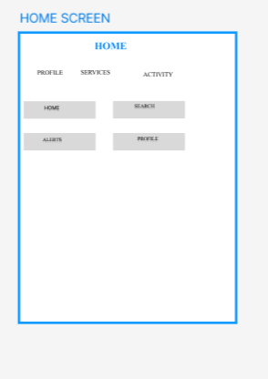
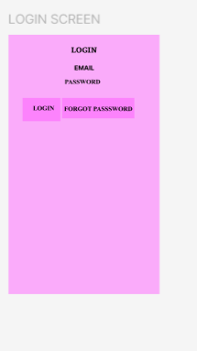
Frame 5: Settings Screen Figure 2: Navigation Flow

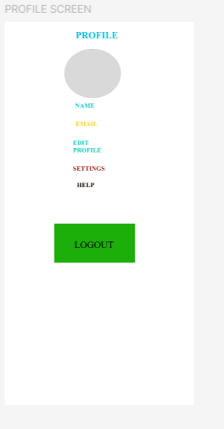
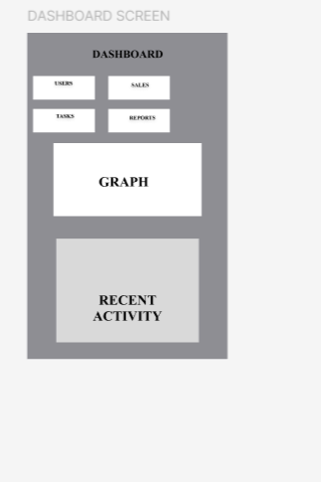
Figure 1: Login UI Figure 2:Home UI

Figure 3: Dashboard UI Figure 4: Profile UI
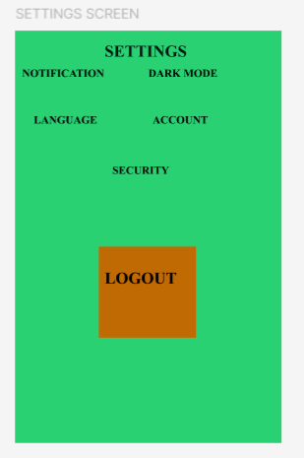

Figure 5: Setting UI
Tools used:
- Figma (UI/UX design and wireframing)
- Android Studio
- Flutter SDK
- Android Emulator

Week 3 Summary
In Week 3, I focused on user interface (UI) development by designing wireframes in Figma and converting them into functional Flutter screens. I implemented layouts, forms, navigation, and basic interactions. I also tested the application on an emulator and improved responsiveness and usability of the interface.
Lessons:
I learned how to design user interfaces using Figma and translate them into Flutter code. I gained skills in building responsive layouts, handling user input, and implementing navigation between screens. I also understood the importance of UI/UX design principles such as spacing, color selection, and usability in mobile applications.

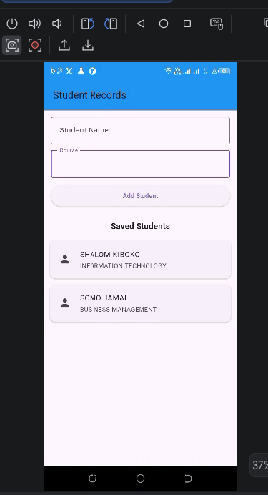
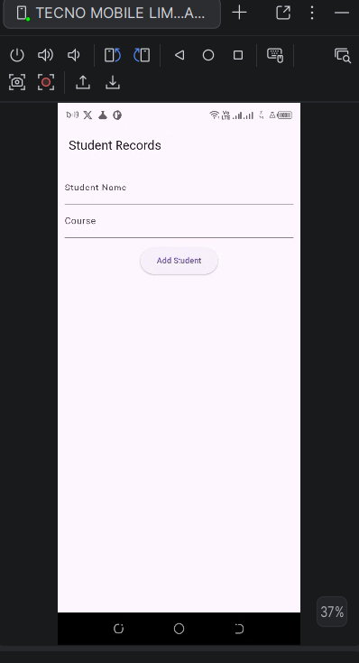
WEEK 4: EVENT HANDLING AND USER INTERACTION

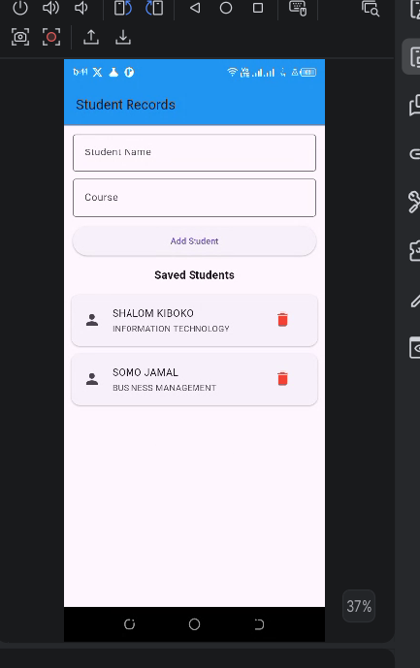
Figure 1: Student Input Interface Figure 2: Student Records

Figure 3: Delete Operation
Tools used:
- Android Studio
- Flutter SDK
- Dart Programming Language
- SQLite (Local Database)
- Physical Device

Week 4 Summary:
I developed a student management application focusing on data storage and CRUD operations. The system included a student input interface, records display, and delete functionality. I learned how to manage and manipulate data in mobile applications using local storage techniques.
Lessons:
I learnt the importance of data persistence in mobile applications and how proper data handling improves application reliability and user experience. I understood how changes in stored data must be reflected immediately in the user interface.

WEEK 5: DATA MANAGEMENT

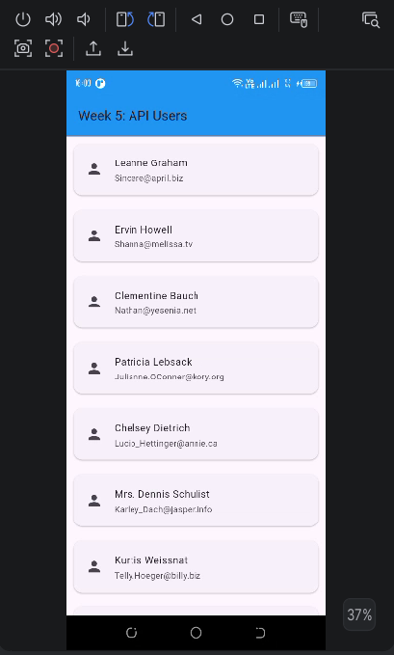

Figure 1:API Screen

Week 5 Summary:
I learned how mobile applications communicate with external servers through APIs. I integrated a REST API into my Flutter application using the HTTP package. The application successfully retrieved user information from a public API, processed JSON data, and displayed it dynamically using Flutter widgets.
Lessons Learned
I learned how to:
- Use REST APIs in mobile applications.
- Send HTTP GET requests using the Flutter HTTP package.
- Parse JSON data received from a server.
- Implement asynchronous programming using Future.
- Display API data dynamically using List View widgets.

